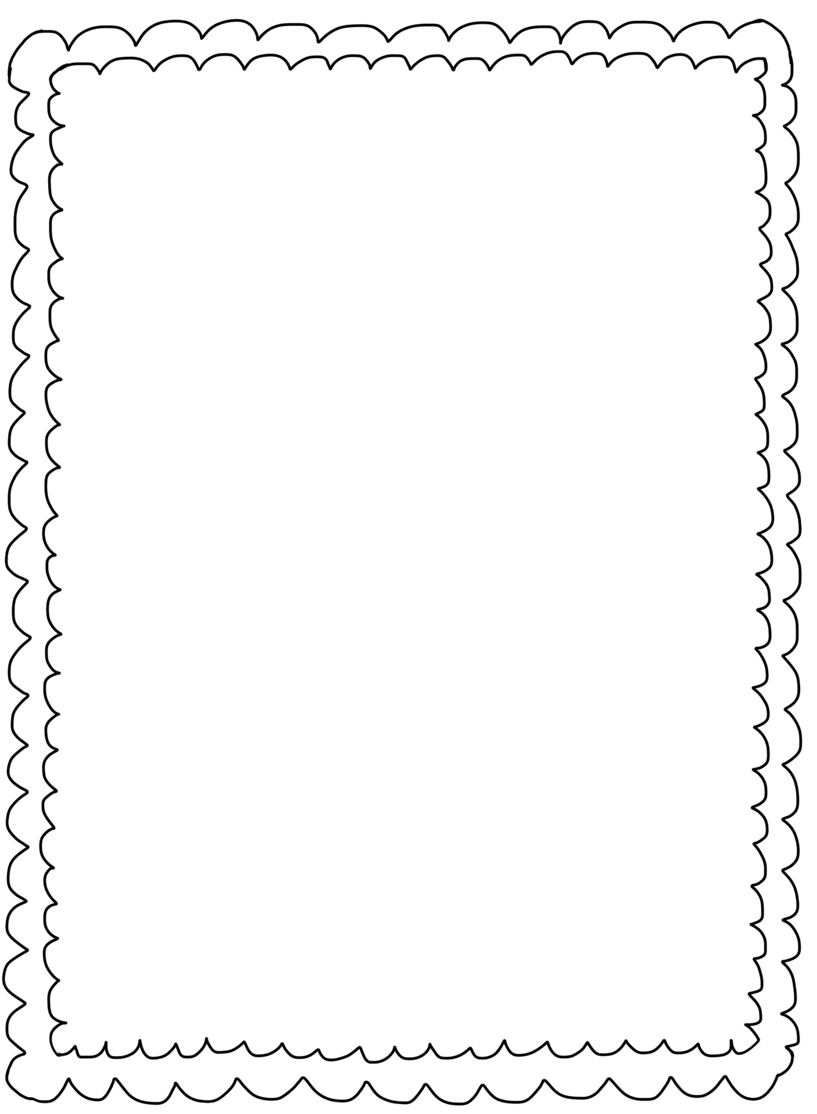

Please send in the following supplies for your student’s personal use:

Notebook Paper

Pencils

Highlighter

Glue sticks

Composition Book

Optional: individual crayons, markers or colored pencils

Optional items for whole class use:

Kleenex, disinfectant wipes, hand sanitizer, paper plates, small cups, individually wrapped candy, fruit cups or snacks for “ticket” rewards.

Thank you!

Mrs. Vicki